# Workshop: Eventmi

This document defines the **workshop** assignment for the [Databases Advanced - Entity Framework course @ SoftUni](https://softuni.bg/trainings/4234/entity-framework-core-october-2023)

One of your friends just started a business as an event organizer. Happily, their business turned out to be extremely successful and your friend has a lot of events that they need to keep track of. Everybody knows that you are taking the Entity Framework Course at SoftUni and your friends asks you for help in order to create a simple web app that should help in keeping track of the events.

Of course, you come to the rescue without having any second thoughts. Your friend shows you a sketch of what the web app should look like and tells you that it's up to you to decide how to build the app and how its architecture should be structured.

Knowing some of the **best practices** for building an app that uses a database, start working on the project. Below are the images, which your friend has showed you and which demonstrate how the app should look like. The needed entity is described below as well. Keep in mind that all of the properties are **required**.

Feel free to implement whatever patterns you feel most comfortable with. If you want, you can add some other functionalities.

## Entities

### Event

* **Id** (**int**, primary key)
* **Name** (**string**, max length – **50**)
* **Start** (**DateTime**)
* **End** (**DateTime**)
* **Place** (**string**)

## Pages

If you are having trouble with the view files, you can use the ones from the Resources.

### Home

This what the Home Page should look like.

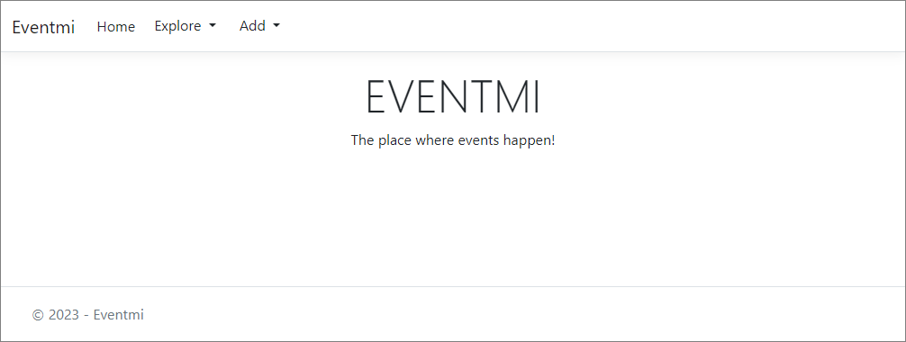

### Add an Event

This is how the Add an Event Page should look like.

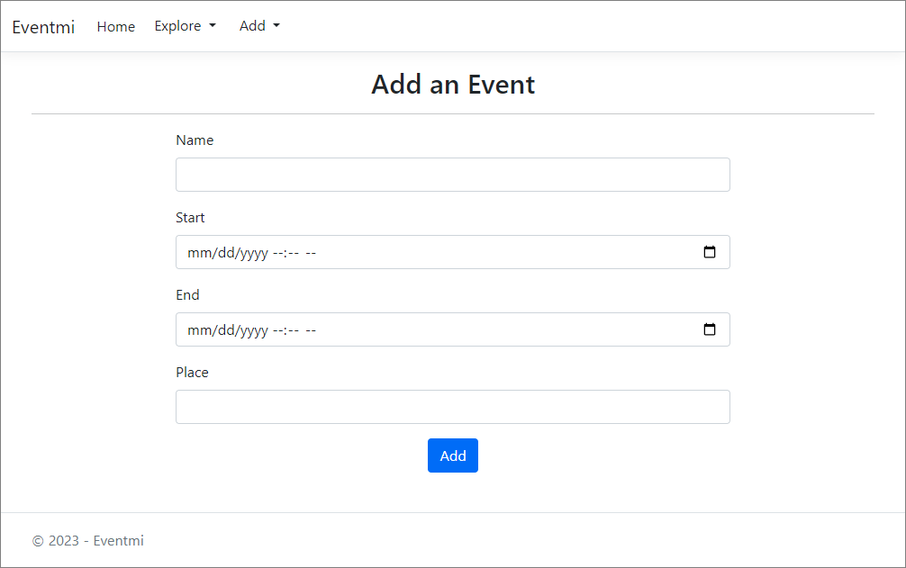

### Edit an Event

This is how the Add an Event Page should look like.

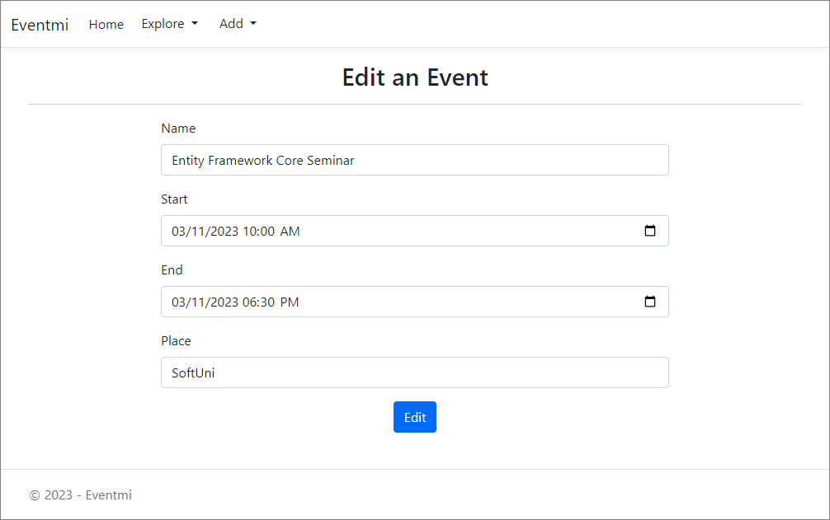

### Delete an Event

You should be able to delete an event.

### View All Events

This is how you should visualize the list of events.

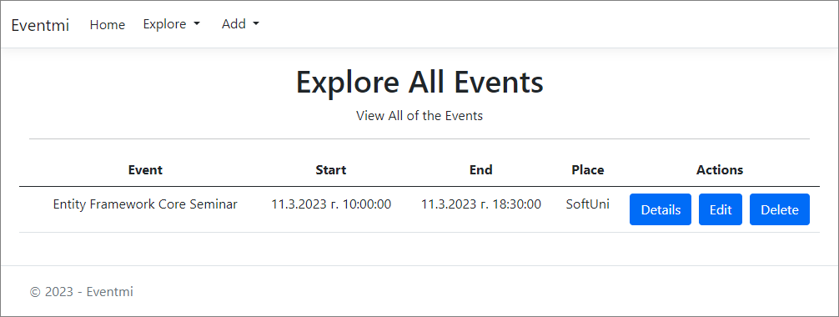

## Functionality

The app users should be able to view all of the events, add new ones, delete and edit already created events. If you want, you can try to implement a functionality for adding a new address and/or a new town.

**Happy Coding! 😊**